**Department of Electrical Engineering**

|  |  |
| --- | --- |
| **Faculty Member: _________________** | **Dated: ____________________** |
|  |  |
| **Course/Section: BEE 12** | **Semester: Spring 2023** |
|  |  |

**EE-351 Communication Systems**

# Lab3: AM Transmission, Amplitude Modulation

|  |  |  |  |  |  |  |
| --- | --- | --- | --- | --- | --- | --- |
| **Name** | **Reg. No** | **Viva / Quiz / Lab Performance** | **Teamwork** | **Ethics** | **Software tool Usage** | **Analysis of data in Lab Report** |
|  |  | **5 Marks** | **5 Marks** | **5 Marks** | **5 Marks** | **5 Marks** |
|  |  |  |  |  |  |  |
|  |  |  |  |  |  |  |
|  |  |  |  |  |  |  |

**Lab3: AM Transmission, Amplitude Modulation**

**Objectives**

Our learning objective for this lab is to get ourselves familiarized with the process of transmission in the communication system and to go through different circuit parts involved in process. First, we will modulate the signal and go through the calculation of their modulation indexes, waveforms. Then we will learn the RF power amplifier applications and its role in transmission.

The AM/SSB transmitter part of the circuit board will be thoroughly covered.

**Lab Instructions**

* The students should perform and demonstrate each lab task separately for stepwise evaluation
* Each group shall submit lab report on LMS within 6 days after lab is conducted. Lab report submitted via email will not be graded.
* Students are however encouraged to practice on their own in spare time for enhancing their skills.
* Complete as many problems as you can within the allotted time.
* Talk to your classmates for help

**Lab Report Instructions**

All questions should be answered precisely to get maximum credit. Lab report must ensure following items:

* Lab objective
* Results (screen shots) duly commented and discussed.
* Conclusion

**Introduction:**

As we looked at the balanced modulator in the last lab today we are going to bring it to use to generate amplitude modulated signal and look its modulation index, envelope form and other characteristics.

Amplitude Modulation:

In AM, the carrier does not vary in amplitude. However, the modulating data is in the form of signal components consisting of frequencies either higher or lower than that of the carrier. The signal components are known as sidebands and the sideband power is responsible for the variations in the overall amplitude of the signal.

The amplitude modulator shifts the frequency of the message signal to that of the carrier signal. The resulting envelope on the modulated signal is the copy of message signal. Its waveform match with that of carrier signal.

Modulation Index:

Modulation index is the parameter which quantifies the peaks in the AM signal. Modulation index is the ratio of amplitude of the message signal to that of carrier signal amplitude.

The method of determining it form of waveform is shown below:

m= (A-B)/(A+B)

To calculate the percentage it should be multiplied by 100.

If the message signal have too much variation we can have a trapezoid representation AM signal. In practical scenarios the voice is such kind of signal which has a lot of variations, one cannot determine the index from the envelope form of the AM signal.

Transmission Efficiency:

It is the ratio of the power contained in the sidebands to that of total powers

P(sidebands)/P(total)

**Lab 3: Lab Tasks**

1. Locate a AM/SSB transmitter and VCO-LO circuit block and connect the circuit as shown in figure 2-6.Be sure to place a two-post connector at the place of 1000kHz on the VCO-LO circuit block. Set switched S1, S2 and S3 to off.

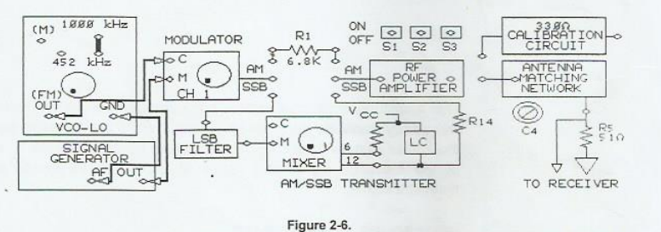

1. Connect the oscilloscope channel 1 to message signal input(M) of the modulator. While observing the signal on channel 1, adjust signal generator to 0.2Vpk-pk, 2Khz sine wave signal at M.
2. Connect the channel 2 probe to carrier signal input(C) of the modulator, while observing the signal on channel 2, adjust VCO-LO for 0.2Vpk-pk, 1000 kHz signal at C. Adjust the carrier frequency with negative supply knob on the base unit and adjust the carrier amplitude with knob on the VCO-LO circuit block.
3. Connect the channel 2 probe to the output of the modulator, Trigger on channel 1.
4. Adjust the potentiometer knob so that the AM waveform of oscilloscope channel 2 has 2V between the upper and lower peaks.

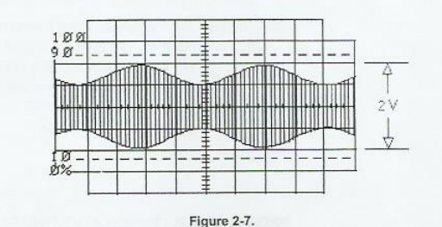

1. Does the AM signal envelope have the same shape and frequency as the message signal.
2. You have set the carrier signal frequency to 1000Khz and the message signal frequency 2Khz. What frequencies are present in the frequency spectrum of AM signal.
3. Change the signal generate function from a sin wave to square wave. Did envelope of the wave change from a sin wave to square wave.
4. Return the signal generator function to sin wave, while observing the AM output signal on channel 2, vary the signal generator AF frequency knob to vert the message signal frequency. Did frequency of the AM signal envelope change to correspond to the frequency of message signal.
5. Readjust the frequency of message signal to 2Khz, while observing the AM output signal, vary the AF level knob of signal generator to vary the amplitude of message signal. Did the AM signal envelope change to correspond to the amplitude of message signal

**Modulation Index and Modulation Percentage:**

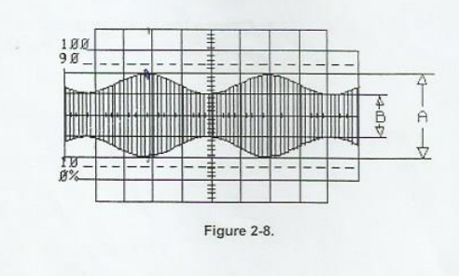

1. Switches S1, S2 and S3 should be off.

1. On oscilloscope channel 1, adjust the peak to peak voltage of message signal to 0.2Vpk-pk. If necessary, adjust the modulators potentiometer knob so that AM waveform shown on channel 2 has 2V between upper and lower peaks. 2V is measurement A in figure 2-8.
2. On oscilloscope channel 2, measure the vertical height (in volts) between upper and lower valleys (measurement B in figure 2-8 of modulated waveform.
3. Calculate the modulation index m.
4. Calculate the percentage of modulation.
5. Whie observing the AM signal on channel 2, increase the amplitude of the message signal until the AM signal envelope waveform touches the reference line as in figure 2-11 the difference represented by B on the AM signal waveform is now 0.0V.

1. On oscilloscope channel 2, measure the vertical distance (in volts) between upper and lower peaks (measurement A in figure 2-11 of modulated waveform.
2. Calculate the modulation index m.
3. Calculate the percentage of modulation.
4. Adjust the amplitude of message signal at channel1 to 0.2Vpk-pk if necessary, adjust the modulator potentiometer knob so that AM on channel 2 is less than 100% modulated and have 2V between upper and lower peaks.
5. Place the oscilloscope in X-Y mode. Adjust the X and Y attenuators to obtain a trapezoidal pattern (figure 2-10). On the oscilloscope measure A in trapezoidal pattern.

1. On the oscilloscope pattern, measure B (in volts) in the same pattern.
2. Calculate the modulation index m.
3. Calculate the percentage of modulation.
4. Are your trapezoidal method measurements of modulation index(m) and percentage modulation similar to the results you obtained using AM signal.

**100% modulation, Over modulation and transmission frequency.**

1. Switches S1, S2. and S3 should be off. Set oscilloscope in the normal mode (out of X and Y). readjust oscilloscope Volt/division and time/division so that signal on channel 2 appears.

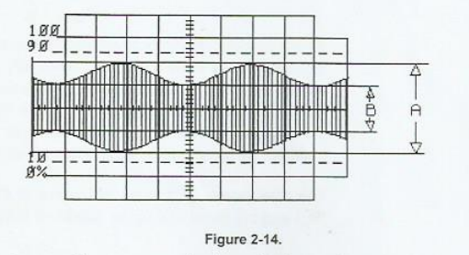

1. Increase the message signal amplitude on channel 1 by adjusting the AF level knob on the signal generator until AM signal as shown appears, it is modulated or over modulated.

28. Is the modulation index of AM signal is greater or less than 1.

29. I overmodulated signal desirable in AM communications.

30. Reduce the message signal so that AM signal on channel 2is 100% modulated.

31. Calculate transmission efficiency. (m^2/(2+m^2).